Committee on Historicity
River Cities Research Commission
2015
Austin R. Justice
Chair, Committee on Historicity
6/23/2015
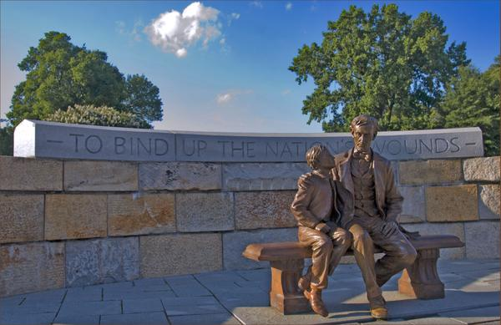
Introduction

Contained in this document is a formal proposal for the creation of the River Cities Research Commission, a subdivision of the Committee on Historicity. One will find a brief overview of its proposed programs, purpose, membership, structure, responsibilities, etc. As the American Civil War sesquicentennial draws to its close, thus reminding our dutiful citizenry that we must perpetually labor to bind up the nation’s wounds, this Commission is one of many progressive reform institutions intended to bind up the Chapter’s wounds.

Purpose
The Commission serves as the research branch of River Cities Chapter. Its purpose is to fulfill and carry out any research or investigation necessary to an endeavor of the Chapter; this includes, but is not limited to: Kentucky History Fridays, information for speeches, information for the Chapter website, information for flyers, information regarding DeMolay as an organization internationally, and/or any other research/information required for any purpose, initiative, activity, program, or otherwise of River Cities Chapter or the membership thereof. Moreover, our aspirations are to utilize this Commission as a progressive reform institution whereby we acquire new members, develop public relation networks, and increase knowledge of the Order of DeMolay among the general populous via our proposed programs.
Membership & Structure
Members of the RCRC are to include the Chair of the Committee on Historicity, who shall simultaneously act as the Commission Chairman; no less than three (3) of the members of the Committee on Historicity, including the Chair. Thus one who is an RCRC constituent is likewise a member of the Committee, though a member of the Committee is not definitively a member of the RCRC.
The Commission is to be a joint HKI-RCD institution. The HKI is responsible for the furnishing of proper research materials/resources whilst River Cities is obligated to perform administrative tasks of the Commission; nonetheless, this partnership is to assert no dominion upon the decisions of the RCRC, the determinative authority of which is vested solely in River Cities Chapter.
As is aforesaid, the RCRC is to be chaired by the Committee on Historicity Chairman. He shall be responsible for all administrative obligations of the RCRC, unless otherwise delegated to another Commissioner. Votes of the RCRC are to be weighed in a non-legislative fashion; such as to mandate that any item be adopted should it receive a majority, be this of 2-3 or 4-3, etc. The Chair of the Commission may enact the Rule of Veto if he sees fit during a vote; this veto must be either sustained or nullified by a vote of the General Membership of River Cities – excluding all RCRC members. Finally, the RCRC is a subdivision of the Committee on Historicity.
Programs
The inaugural RCRC program is the River Cities Research Commission Fellowship. This Fellowship – open to all high school and university students, regardless of age or gender – entails a term or year-long (depending on the preference of the Chapter) researcher position for five individuals per fellowship selection cycle. Such fellows will be given the opportunity to perform curatorial research for River Cities’ necessities and for Kentucky History Fridays; further, they will be assigned articles to write as adjunct contributors to the Chapter’s Kentucky History Fridays Program. Submitted articles and research must be reviewed and cross-referenced prior to publication or use; therefore this program simultaneously acts as a learning experience for fellows, wherein they are mentored in the annals of historiography and social science research. All fellows will work closely with the RCRC Chairman, and with the HKI which will provide all proper resources and mentorship.
The RCRC Fellowship Program is the premier initiative of the Commission. Whilst it provides a résumé strengthening experience for youth, who act as student historians throughout the program, hence expatiating their social science knowledge/interest and deeply enhancing our community and local school systems, it also affords a reformation to RCD membership/public relations.
The Program will be open to all genders and ages (excluding those below the high school level.) We are thereby offering DeMolay leadership and precepts to the wider youth population – circa ½ of which is barred from DeMolay membership. More significantly, this Program – which will be advertised by local schools, counselors, and most assuredly the James Klotter Chapter of the Rho Kappa National Social Studies Honor Society – will act as a membership outreach project. Males of the specified age groups who receive word of the Program are prompted to search for the answer to the question: What is DeMolay? Oft our numerical membership woes are due to severe lack of public knowledge regarding our benevolent Order. Students, regardless of their choice to apply or reject the notion, thereafter are effectually public networkers for the Chapter: in the same manner that news spreads throughout a public body, these students will weave the idea of DeMolay into the minds of their peers. Although we may not gain a majority of such peers for the Fellowship, these de facto town criers inevitably implant a curiosity into the young mind.
Those so electing to apply and whom are accepted as RCRC Fellows will likewise spread word of the Program and thus our Order to likeminded peers and friends. Whereas our female fellows cannot directly partake in our organization, they too shall be heralds by which word of DeMolay is spread to the general public. Our endeavor will advertently weave a complex web of positive public relations which could potentially sustain interest in our Chapter for successive generations; in addition, due to the academic nature of the fellowship, we will gain considerable favor among public and private educational institutions.
Young citizens undertaking this great academic trek will be enriched with theretofore unknown methods of historiographic thought/analysis, writing, leadership, and skill. River Cities will have the privilege of attracting bright minds to its metaphorical doors as they seek fellowships, while assisting in the ongoing reformation of Kentucky’s tumultuous education system; youthful scholars whose pioneering minds are furthermore fostered by our fellowships will continue to excel in their formal studies, raise local test scores, thus receiving greater percentages of acceptance to renowned institutions such as the University of Virginia or Brown University – comparatively, a majority of Boyd County graduates flood Morehead State University, the University of Kentucky, and the University of Louisville, all of which are the flagship post-secondary education centers for the Commonwealth yet somewhat lacking when given to comparison with other top public universities, i.e. the University of North Carolina-Chapel Hill. These scholars then either return to our humble community, revitalizing the local economy, or they enter the wider world of humanity and spread the precepts of DeMolay internationally.
It is entirely reasonable to predict that this wonderful academic service, offered free of charge (instead opting for a merit-based application process,) will increase the numerical membership twofold; and it will forge a favorable perception of River Cities Chapter in the region.
Conclusion
The innumerable benefits of the River Cities Research Commission and RCRC Fellowship Program are utterly vital to the sustainability and survival of our Chapter. It must be the first of many implementations aimed at progressive Chapter reform. Formal adoption and effective incorporation of this Commission and its accompanying Fellowship are certain to institute a swift momentum of reform and reconstruction within Kentucky DeMolay; River Cities shall once again lead our noble State as the exemplar of DeMolay among Kentuckian chapters. As our unique endeavor ever swells the rank and file of our home Chapter, we may rest assured that a glorious wind of change is mustering and preparing to wail across our Commonwealth in order to bind up the jurisdiction’s wounds.

